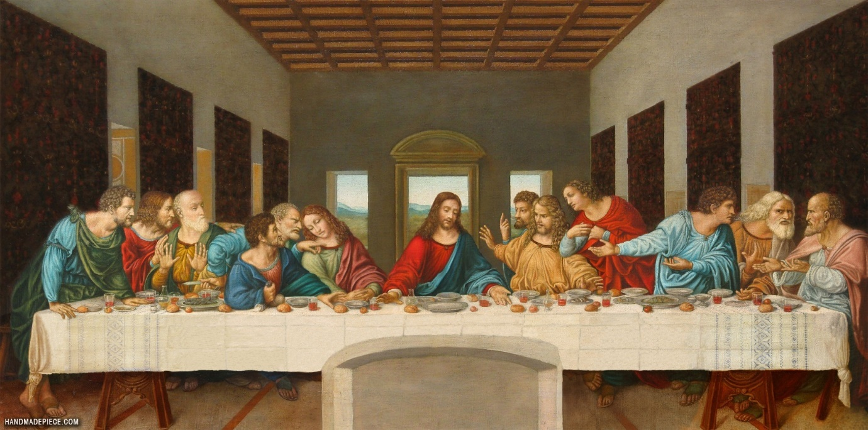
This half term we have been looking at significant people in the Easter story.
Choose either Peter or Judas and write a reflective diary entry. Below are some ideas for your diary entry. Your diary entry should be one or two paragraphs long.

This is activity should take you two weeks leading up to Easter

Peter
Imagine you are Peter:
John 18: 15-27,
Acts 2: 14-41;

Who was he?
What was his role in the Easter Story?
What does Peter’s denial say about the challenges of Christian faith?
How did Peter’s actions affect himself, Jesus, the crowd?
How did Peter feel and react to the events in the Easter Story?

Matthew 26:17-30,
Mark 14: 12-26,
Luke 22: 37 and 38,
John 13: 18-38;

Judas
Imagine your are Judas:
Who was he?
What was his role in the Easter Story?
Does Judas’ actions and the consequences teach us anything?
How did Judas feel and react to the events in the Easter Story?

Helpful online resources:

The ‘Miracle Maker’ online provides great clips

The Crucifixion and Peter's denial

https://www.bbc.co.uk/bitesize/clips/zwb9jxs

Challenge

The Easter Story Pairs Game

http://request.org.uk/restart/2016/02/03/the-easter-story-pairs-game/

