Investigating the Ancient Egyptians using Espresso

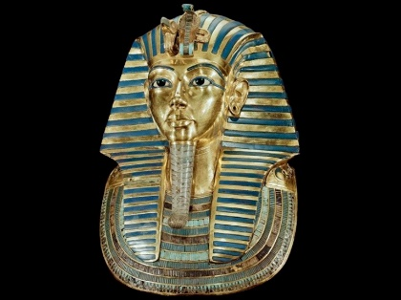
People Part 1
1: Why is Tutankhamun a well-known king?
2: Where and when was his tomb discovered?
3: What was discovered in Tutankhamun's tomb?

People Part 2
1: Name four objects found in Tutankhamun's tomb?
2: What animal appears on the pharaoh’s gold chair?
3: What did modern scans of Tutankhamun's body reveal?

The Nile
1: Write three facts about the River Nile.
2: How did the River Nile help the ancient Egyptian people?
3: What were boats used for on the Nile?

Life Part 1
1: What did the Egyptians believe would happen to them when they died?
2: How did Egyptians preserve dead bodies?
3: Why were Egyptians buried with their belongings? What things were they buried with?

Life Part 2
1: What was the difference between the way the rich and poor Egyptians were buried?
2: How were kings and queens buried?
3: How high is the 'Great pyramid'?

Evidence Part 1
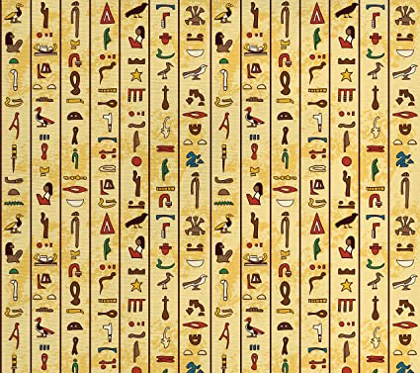
1: What different types of evidence do you see in the video?
2: What can be found in the tombs of wealthy Egyptians?
3: How do we know about the clothes that ancient Egyptians wore? What did they wear?

Evidence Part 2
1: What did ancient Egyptians eat? How do we know?
2: What are hieroglyphs?
3: List three types of evidence shown in this video. What does each type tell you about the Egyptians?

