Year 1 | AUTUMN 1 | AUTUMN 2 | SPRING 1 | SPRING 2 | SUMMER 1 | SUMMER 2
MAIN  TEXTS  +  WRITING OUTCOME | 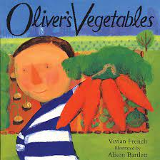  Oliver's Vegetables  by Vivian French  Outcome: Recount  (Visiting a family member)  Audience: Year 1  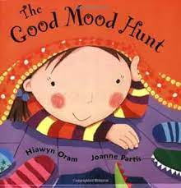  The Good Mood Hunt  by Hiawyn Oram  Outcome: Emotive writing  Audience: Year 1  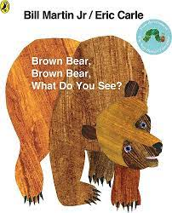  Brown Bear Brown Bear,  What do you see?  Outcome: Rhyming poetry  Audience: Year 1 | 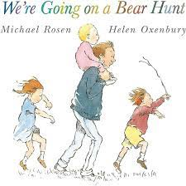  We're Going on a Bear Hunt by Michael Rosen  Outcome: Sequencing/ retelling  Audience: Reception  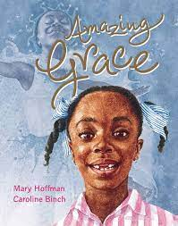  Amazing Grace  by Mary Hoffman  Outcome: Diary entry  Audience: Year 1  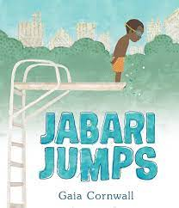  Jabari Jumps  by Gaia Cornwall  Outcome: Narrative from another perspective  Audience: Year 1 | 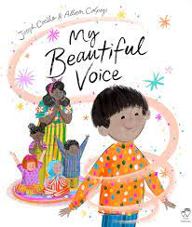  My Beautiful Voice by Joseph Coelho & Alison Colpoys  Outcome: Performance poetry  Audience: Reception  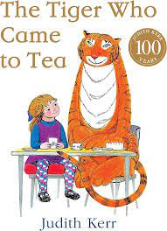  The Tiger Who Came to Tea  by Judith Kerr  Outcome: Recount and Retelling.  Audience: Year 1 | 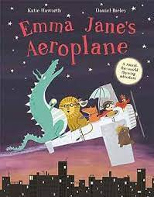  Emma Jane’s Aeroplane  by Katie Haworth  Outcome: Fact file: Places  Audience: Teachers for Summer holidays  Recount/ fact file – toys from the past  Text TBC | 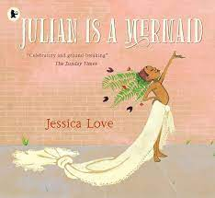  Julian is a Mermaid by Jessica Love  Outcome: Description  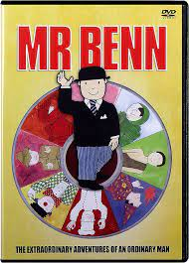  Mr Benn-Red Knight  by David Mckee  Outcome: Narrative  Audience: Year 4- Portal story | 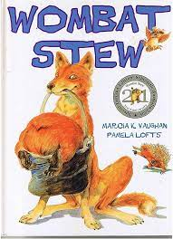  Wombat stew  By Marcia Vaughan  Outcome: Instructions  Audience: Year 2  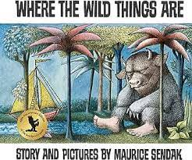  Where The Wild Things Are by Maurice Sendak  Outcome: Fantasy story  Audience: Year 2
Poetry anthologies
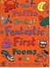
Puffin Book of Fantastic First Poems
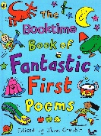
SUPPORTING TEXTS  Linked to other curriculum areas / used in Guided Reading | 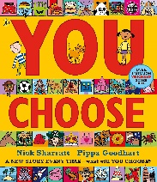  You Choose  by Nick Sharratt and Pippa Goodhard | ? | 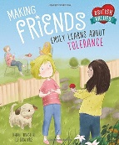  Making Friends: Emily Learns about Tolerance  by Deborah Chancellor  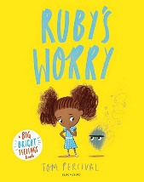  Ruby’s Worry by Tom Percival | 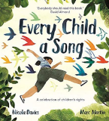  Every Child a Song  by Nicola Davies  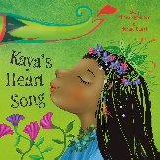  Kaya's Heart Song  by Diwa Tharan Sanders | 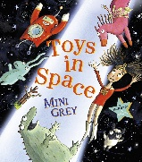  Toys in Space  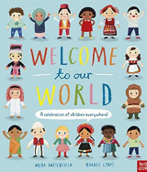  by Mini Grey  Welcome to our World  by Moira Butterfield | 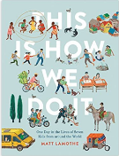  This is How We Do It  by Matt Lamothe
Last edited: December 2023

