Dear Parents/ Carers,

At King’s we use the Jolly Phonics Scheme to teach Phonics in Reception and Year 1, the way your child’s reading at home will be a little bit different. Your child will bring home one fully decodable Jolly Phonics book at their phonics reading level. Class teachers will also give between 1-3 books that belong to other reading schemes to supplement their reading skills. These books may have different ‘colours’ or ‘levels’ on them and you may receive an assortment (e.g. an ‘orange’ and ‘turquoise’) but please disregard this as we are no longer using that colour system and your child’s class teacher will have chosen these as they will be mostly decodable but may have some tricky words that they haven’t learnt yet. They will also bring a self-chosen ‘reading for pleasure’ book, which is for you to read to your child and will provide children with a language-rich experience and is a good opportunity to practise their predicting, inference and comprehension skills as well as developing ideas and understanding of high-quality text which they will apply in their writing.

Your children will only change books once a week on their specific guided reading day, which is why they will be bring home more than two books. As your child will only be able to change their books once a week, we have put together some ideas, questions and challenge activities that your child can do based around the books they have for the week to ensure that they are having a holistic learning experience when reading at home as there is so much more to reading than simply decoding the words.

When reading with your child…
- Encourage your child to discuss the content and style of the book, giving their opinions and reasons for liking or disliking it.
- Discuss the plot, setting, characters asking questions about why events happened or characters behaved in a certain way.
- Look at the emotions of the characters, how do they feel? Why?
- Make predictions and give reasons for thinking this might happen.
- Talk about different aspects of the book – is it fiction or non-fiction? Who is the author/illustrator? Does it have a contents page? Index page? What are these used for?
- If you come across an unfamiliar word, write it down and then find out the meaning together. Maybe you can use picture or contextual clues or a dictionary… Can you use it in a sentence now? Can you write the sentence?
- Look closely at punctuation and use this to add expression, infer meaning and keep a steady pace.
- Use intonation and expression when reading
- Discuss the layout of the book, pictures and purpose of the purpose of the pictures… what difference do they make to the story? Do they help you when you are reading?
- Encourage them to think of alternative endings for the story and challenge them to write these.
- What could happen to the characters next? Could they go on a different adventure? Can you think of one and write your own story using these characters?
- If reading a non-fiction book, choose the most interesting thing you’ve learnt about and find out more about it. Can you create a poster to teach others about all of the fantastic things you’ve learnt in the book?
- Write a short book review on a post-it note or A5 piece of paper and leave it in the book so the next person who reads it can see what you thought about it!
Key Questions
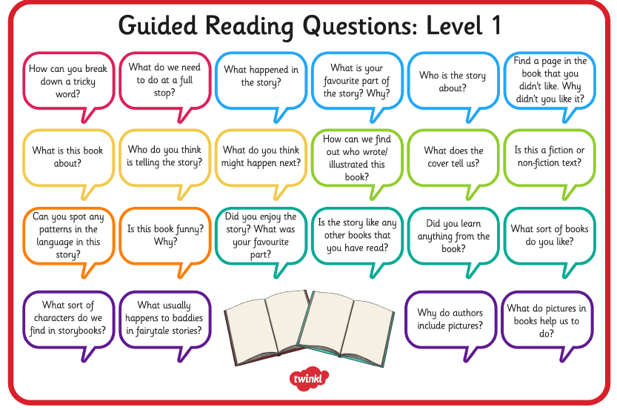
Questions to support your Child’s Reading at Home

If you still feel that your child would like to read more books during the week, Jolly Phonics (https://www.jollylearning.co.uk/jolly-phonics-e-readers-now-available/) and Oxford Owl (https://home.oxfordowl.co.uk/reading/free-ebooks/) both have books that can be accessed online.

Please do not feel that you need to do all of these activities and questions each week, we have provided a range for you to choose from and to vary your child’s reading experiences each week.

If you have any questions, please speak to your class teacher. Thank you for your continued support.

Kind regards,

Year One Team

