Dear Parents/ Carers,

In Year 2, we continue to teach phonics. As you will have noticed children will either bring home one fully decodable Jolly Phonics book at their phonics reading level plus between 1-3 books from our other reading scheme books closely linked or just a couple of books from our Reading scheme from the same colour level. Children can also choose themselves a ‘reading for pleasure’ book, for you to read to your child providing a language-rich experience and an opportunity to practise predicting, inference and comprehension skills as well as developing ideas and understanding of high-quality text which they will apply in their writing.

Your children can change their books every day if they need to. It is important to read their phonics level book several times because we know that rereading books will develop different skills. For example, reading the first time will use decoding skills, second time is practice of decoding, third time is to understand what they have read and so on. Teachers listen to each child read their reading scheme books once a fortnight regularly assessing and moving colours only when children are ready. They also listen to each child read during daily Guided Reading sessions.

Here are some question prompts to develop their reading comprehension.

One-to-one reading process
- Look at the cover
– What might this book be about? How do you know/ why do you think that?
- Who is the author/illustrator?
- Child reads to you
    - Support reading unfamiliar words (use strategies list)
    - If the book was challenging, use one of the fluency strategies
    - Ask comprehension questions (use prompts bookmark)

Unfamiliar words strategies:
- Use phonics fingers to segment the word
- Blend the sounds
- Divide the word into syllables
- Skip the word and then go back (what do you think it might say)
- Look for the parts you know like the beginning or end of the word
- Finally, make a best guess – does it sound right? Does it make sense? If not re-read and try again.
- Know when to just tell them

Fluency skills
- Using expression: capture the mood, show understanding of what the character is like
- Pace: not too fast or slow to help the listener understand
- Phrasing: grouping words for meaning
- Stress: putting emphasis on words to show meaning
- Intonation: rise and fall, quiet and loud to reflect meaning
- Volume: change volume to create emphasis
- Taking account of punctuation: pausing for meaning
- Accuracy: not missing words, dropping endings, mispronouncing vowels, noticing and self-correcting errors
Strategies to develop fluency:
- Choral read – read together at the same time
- Partner read – take turns to read a sentence at a time
- Echo read – adult read, pupil read back in exactly the same way
- Copy read – pupil follow while you model segmenting, blending, using punctuation etc

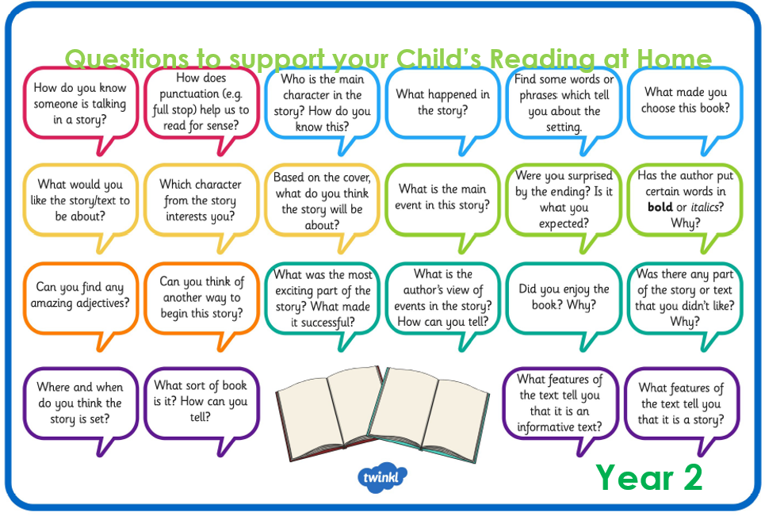

If you still feel that your child would like to read more books during the week, access Jolly Phonics e-readers at https://www.jollylearning.co.uk/jolly-phonics-e-readers-now-available/ or you could join your local library such as Kew Library in North Road open Tuesday and Thursday 10am-6pm and Saturday 9:30am-4pm.

Please do not feel that you need to cover all of the skills and questions each week, we have provided a range for you to choose from and to vary your child’s reading experiences each week.

If you have any questions, please speak to your class teacher. Thank you for your continued support.

Kind regards,
Year Two Team

